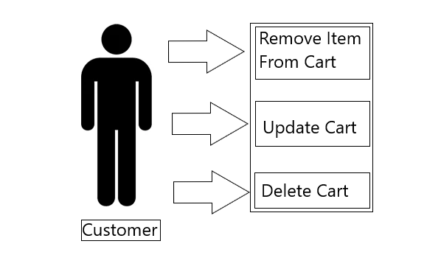

Customer Cart Diagram

The above diagram depicts the interaction between a customer and an item cart on Karoline’s webpage. The customer is the actor in 3 different use cases. The customer can remove an item from their cart, update their cart, and delete their entire cart.